P.O. Box TN 1446
Teshie-Nungua Estates
Accra

REF. NO: STRA/PR/V.2/ED/21/24 25th November, 2024

For immediate release:
STRANEK-AFRICA ON THE INTENTIONS OF GOVERNMENT TO DISRUPT INTERNET ON ELECTION DAY.

This year is a vulnerable political year and with barely few days to elections, there are some perilous developments that can threaten our peace, unity, stability in Ghana.
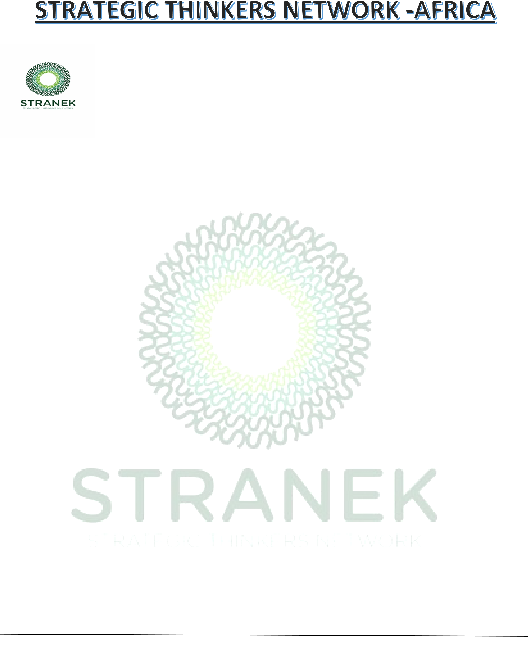
Internet disruptions are a blunt instrument for interrupting the spread of disinformation online but government often deny the entire cities access to communication tools at the time where they need it the most to dispel rumours or avoid dangerous areas. Internet disruptions are some of the signs of Internet shutdown. Internet shutdown is where government orders its authority in charge of internet to stop connections and that is like turning off your modem or Wi-Fi or data but in this case, it is done for the whole country. Countries such as Uganda, Sudan, China et cetera have shut down internets in their country and used national security, public safety among others as a veil to shut down internet but the effects of an internet shutdown go beyond simply cutting off people’s access to information. Internet shutdown can bring financial losses. This action can cause in bad deeds with the confidence that the world will neither hear nor see.
Over the last few months, consumers have complained about poor quality of service-related network and internet disruptions. Unfortunately, the National Communications Authority, the Ministry of Communications and
Digitalization and the Chamber of Telecommunications have failed, neglected and refused to explain to Ghanaians what is responsible for this situation.
STRANEK-Africa is deeply concerned about this development given the adverse effects of the 2023 internet disruptions that affected citizens and businesses in Ghana and other parts of African and Europe.

Website: www.stranekafrica.org, Email: stranek.gh@gmail.com, Twitter: @stranekafrica, Facebook: @stranekafrica Tel: +233 559 042 914

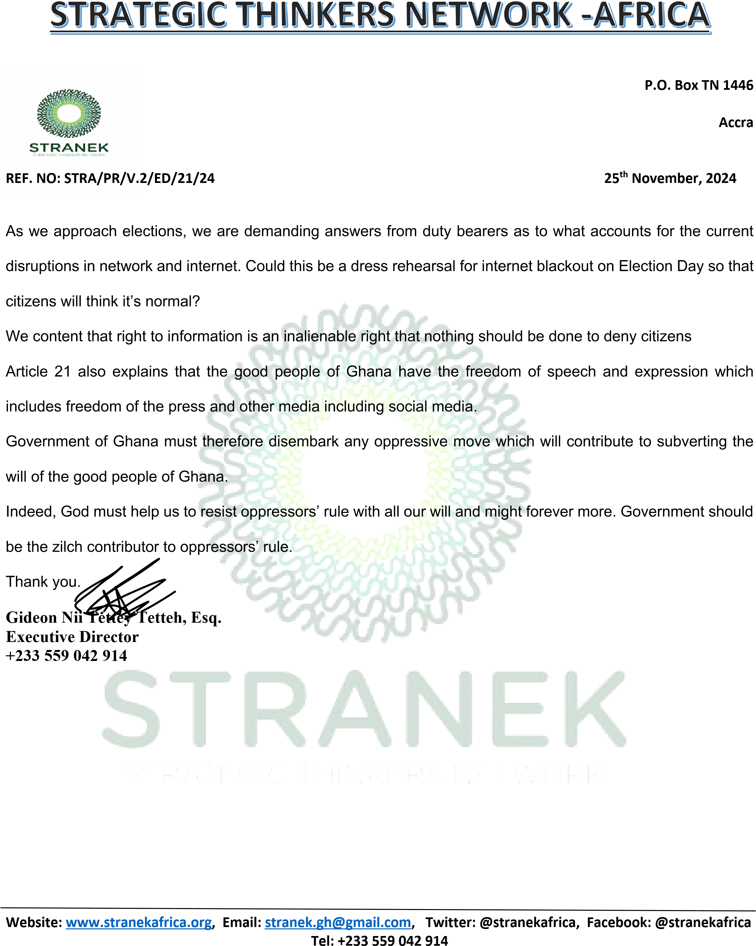
Teshie-Nungua Estates

