HON. DANIEL KESHIE BESSEY, ADA WEST (SEGE) MEMBER OF PARLIAMENT (MP) HOLDS TOSA ’96 TO A DINNER AND A NIGHT OF APPRECIATION AT BOSPHORUS RESTAURANT AND CAFÉ
FRIDAY 3RD JANUARY 2025
Introduction
Hon. Daniel Keshie Bessey, MP for the Ada West (Sege) constituency on Friday 3rd January hosted his former colleagues and school mates from Tema Secondary Schol - TOSA ’96 to a dinner and appreciation party at the Bosphorus Restaurant and Café at Labone. The essence of the get-together was to show appreciation to his colleagues who had in diverse ways supported his campaign by providing spiritual support and standing in the gap for him while he was contesting for the seat. He was particularly grateful to them for their physical presence at the constituency before and during the day of the election, and for joining him to move from one electoral area to the other to monitor the election.
He recounted how the team supported him during his first attempt at the primaries, and even though he lost at the time, the constituents felt the team's presence. In his words, he was surprised to see the team mobilize financial support for him this year, for which some sent money to him directly. He said he could not believe that during his fundraising at Sege, the team drove from their various homes to come and support him. He also said that words may not be able to express his gratitude to us all but deep down in his heart, he holds us all in a very high place.
The night saw many of school mates, particularly Tema Secondary School Old Students Association (TOSA ’96) members, some family members, and friends passing through.
Highlights of the program
Dr. Dr. Felix Kodzo Besah Sorvor who spoke on behalf of the TOSA ’96-year group congratulated Hon. Daniel Bessey on his victory and for projecting Tema Secondary School through his success as well as his tenacity and persistence over the period, saying it exemplified the true nature of the Temascan; which is “always the best”.
Hon. Daniel Keshie Bessey took time to acknowledge and express gratitude to each person at the party. Starting with his wife, Mrs. Genevieve Bessey, which he jokingly referred to as his “dear Rebecca”, the MP moved from table to table to personally thank them for the support and for honouring his invitation to the get-together.
In response to a question that sought to seek the average number of years it takes for one to become an MP, Hon. Bessey indicated that the dynamism varies and may not be the same across the board. He said things have changed considerably because the constituents expect to see one around and to relate to them in terms of their daily living. The people have become very wise, and it is no longer about you having money and treating them anyhow. They would love to see you around.
He also said that they would want to contact you directly sometimes and would want to see you attend their programs and some activities that they consider important. Basically, you should be aiming at between 8 and 12 years of physical presence and activity in the constituency to be considered. Additionally, you should be seen doing some ground activities with these people, to make your intention known to them. If you have been a constituency executive before, the better.
He indicated that having support from your family is critical. Contesting for the parliamentary seat is not only financially demanding but could be emotionally stressful. For those who are married, your wife is your greatest support. Indeed, he used the opportunity to thank his wife very much for standing by him and always reassuring him that they are not giving up until they’ve gotten to the very ultimate. His wife has been a great pillar in his life. Indeed, she has always supported his dreams and has been fully part of them.
He indicated that his doors are always open for advice and constructive criticism. For him he has two constituencies he represents, the Ada West (Sege) where he is mandated to ensure the people’s worth is improved, and Tema Secondary School where he must live as an example for future generations.
He reiterated the need for people to strive to belong to their various old student groups and platforms and to support one another in all their activities. He indicated that amidst the many great plans he had for the people of Sege, he was considering enrolling them into some form of socio-economic insurance that takes care of family demands such as funeral support and job opportunities.

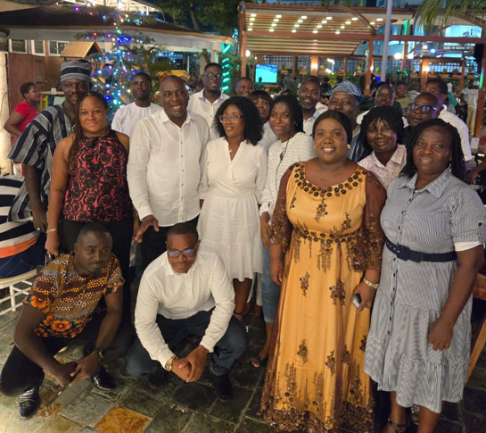
Hon Daniel Keshie Bessey and the TOSA ’96 Year Group
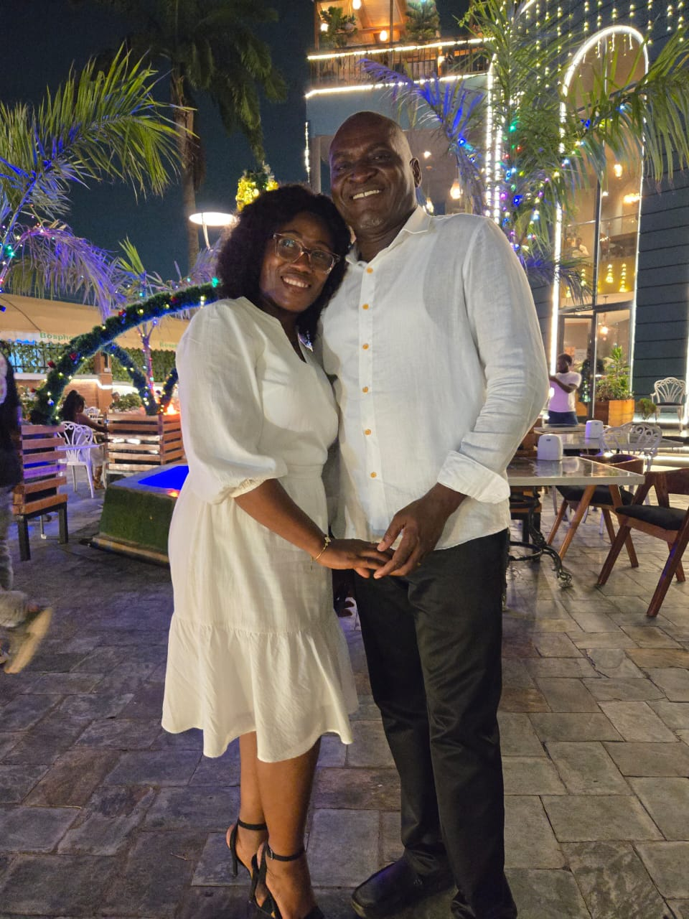
Hon. Daniel Keshie Bessey and his wife Genevieve Bessey at dinner night

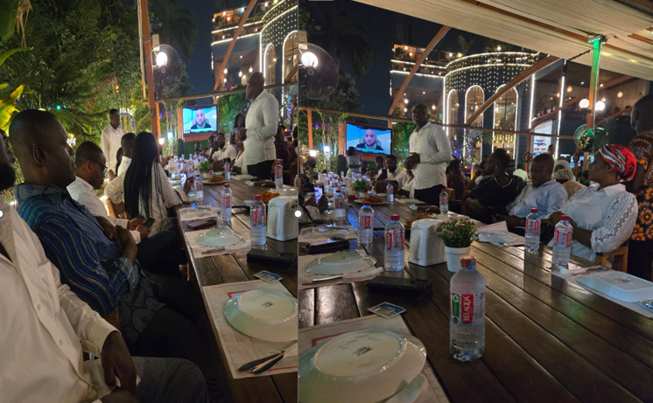
Hon. Daniel Bessey addressing the TOSA ’96 year group

